­­Portfolio Docum­­­entation

Navigation bar

(on scroll there should be and animation and then the content should come )





Hero Section

<https://rainbowit.net/html/inbio/index-white-version.html>

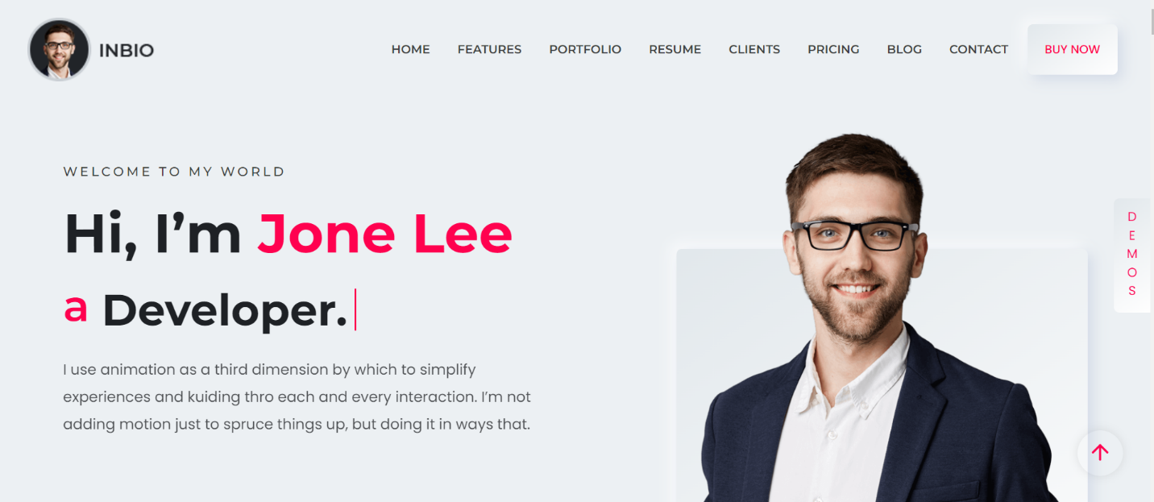

Parallax effect

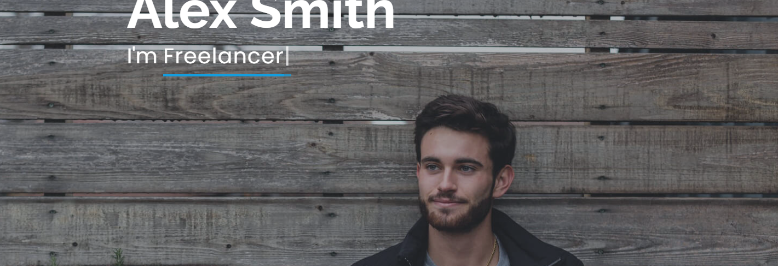

About Me

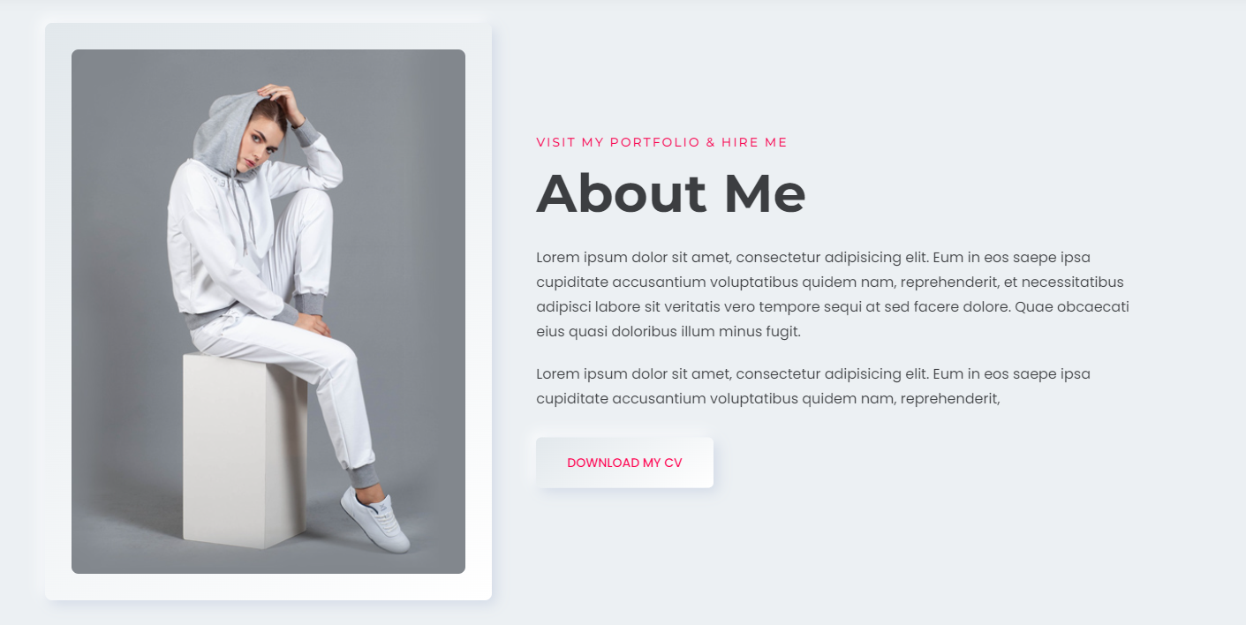

Features section

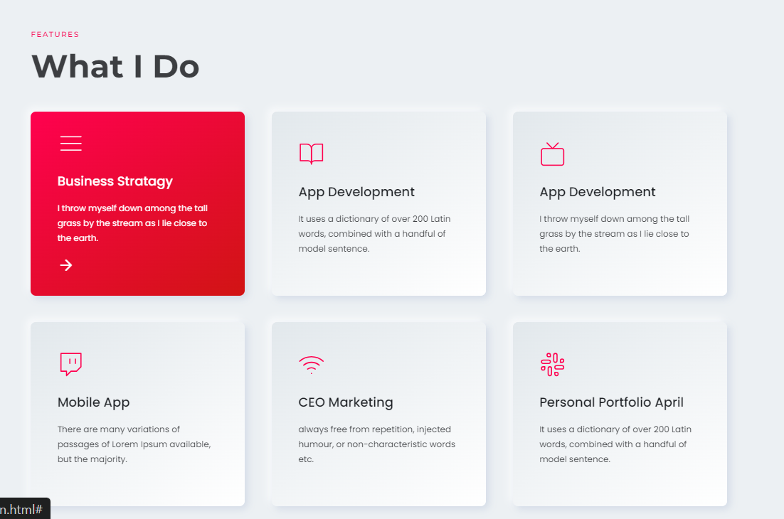

In this the animation should look like this

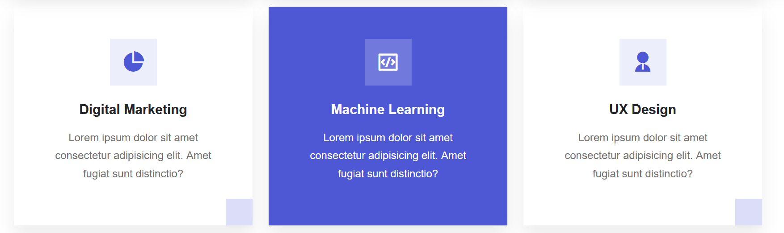

My latest projects Section

<https://sulaimsarran.vercel.app/>

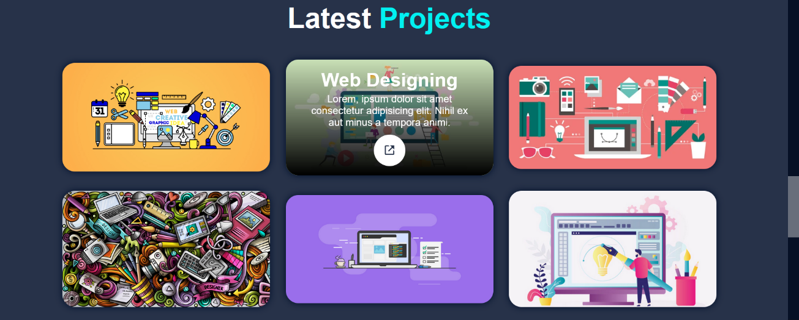

In this there should be animation up words and then the link of project should pop up

Resume

(This should be time line)

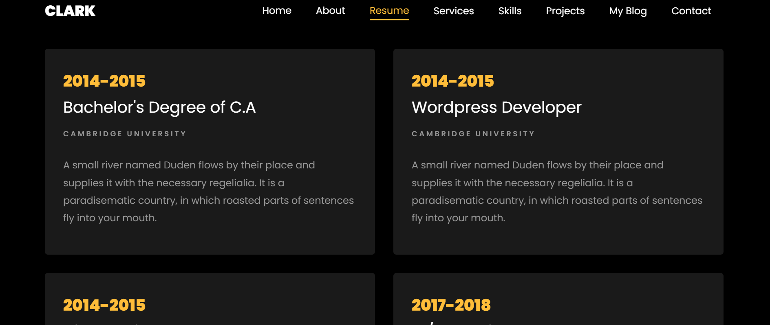

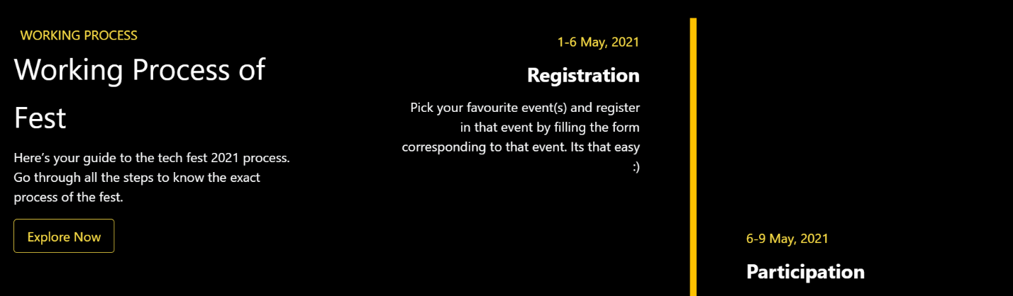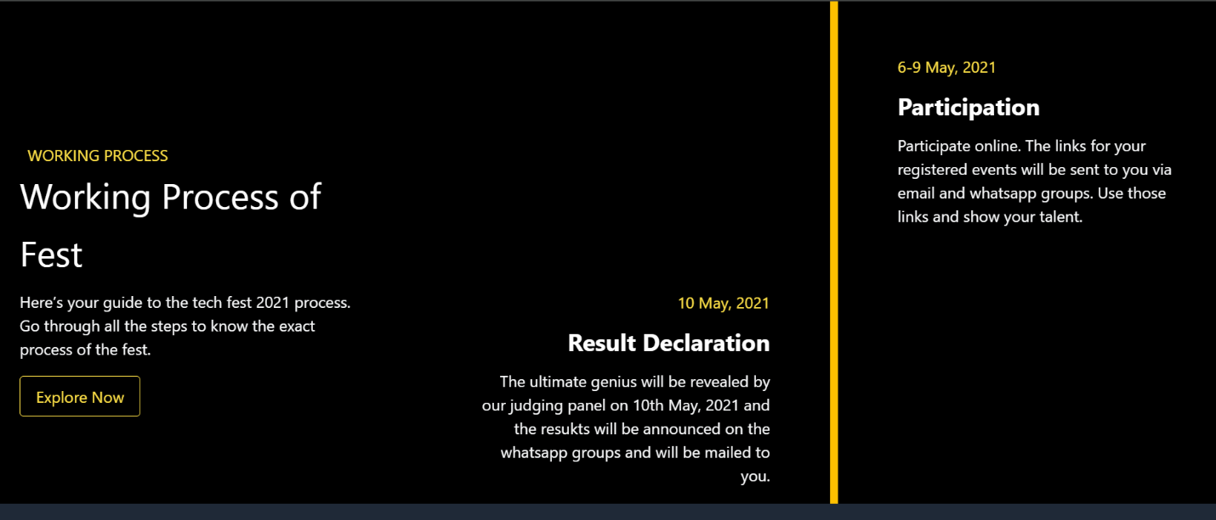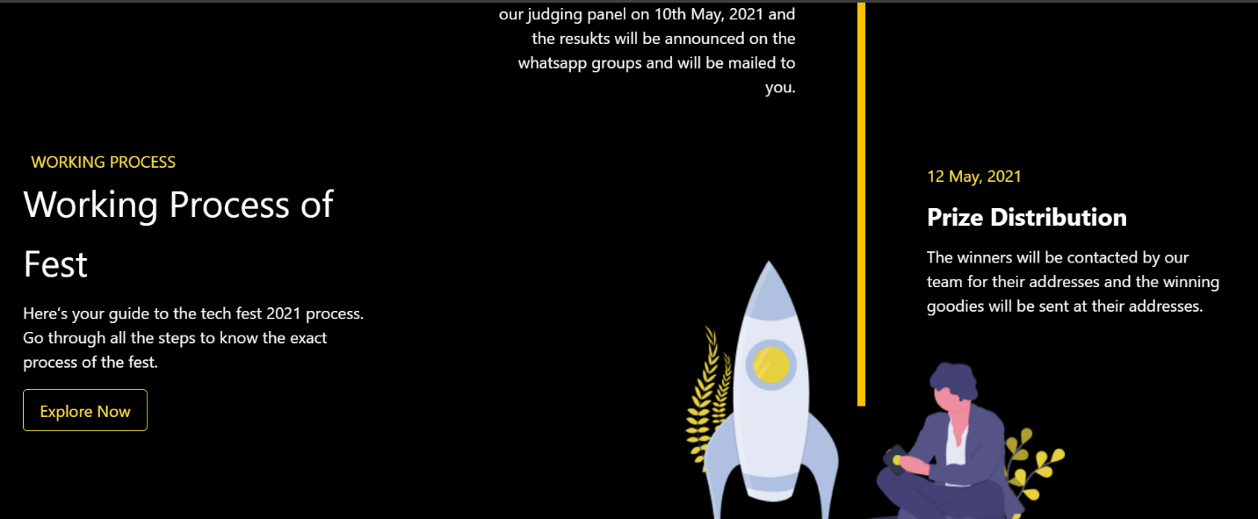

Icons or skills section

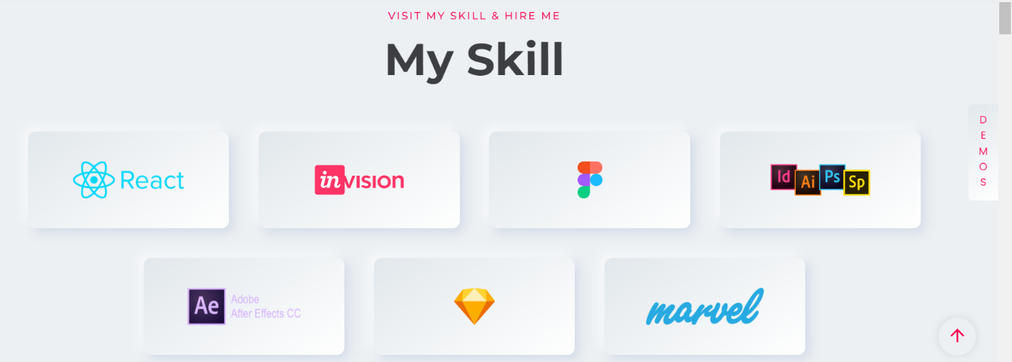

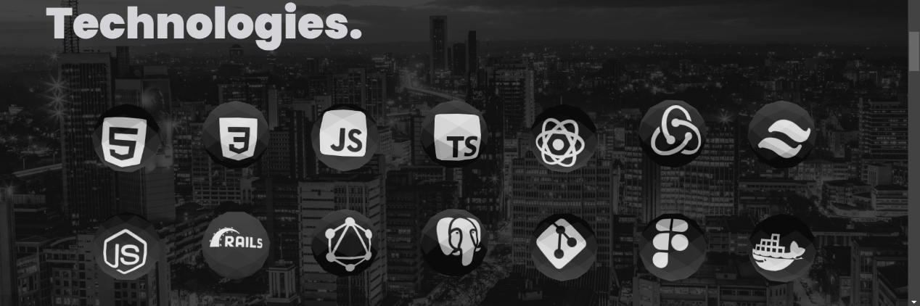

Or

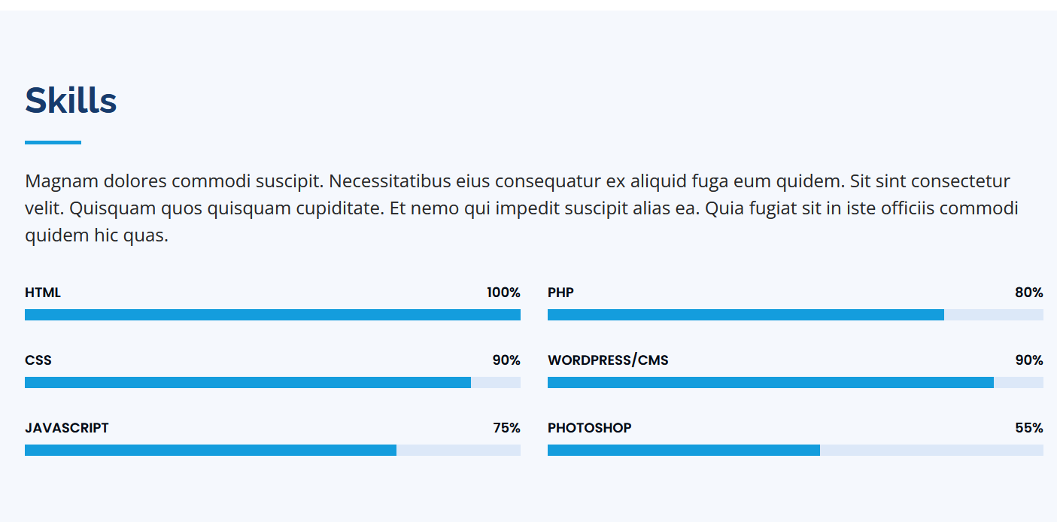

Instagram feed

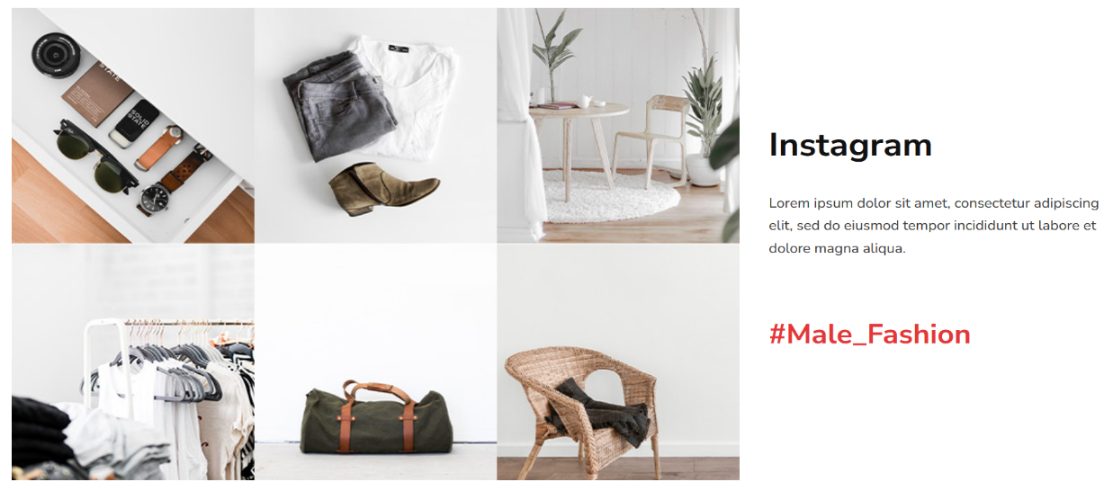

Testimonials

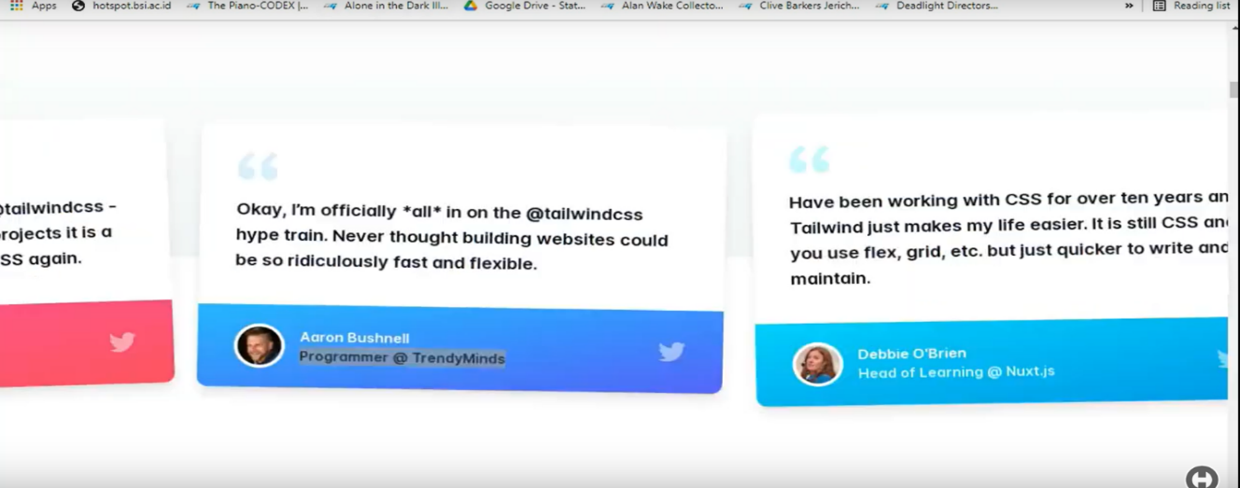

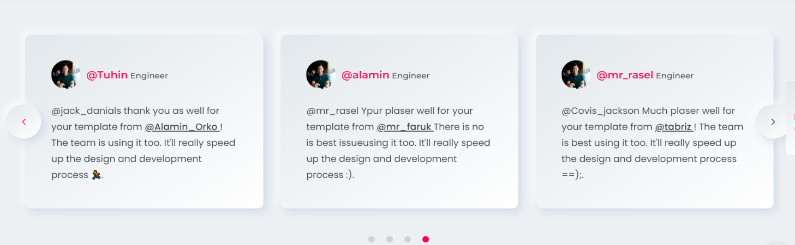

Contact me

In place of get in touch it should be HIRE ME and there should be a background image it should be like this

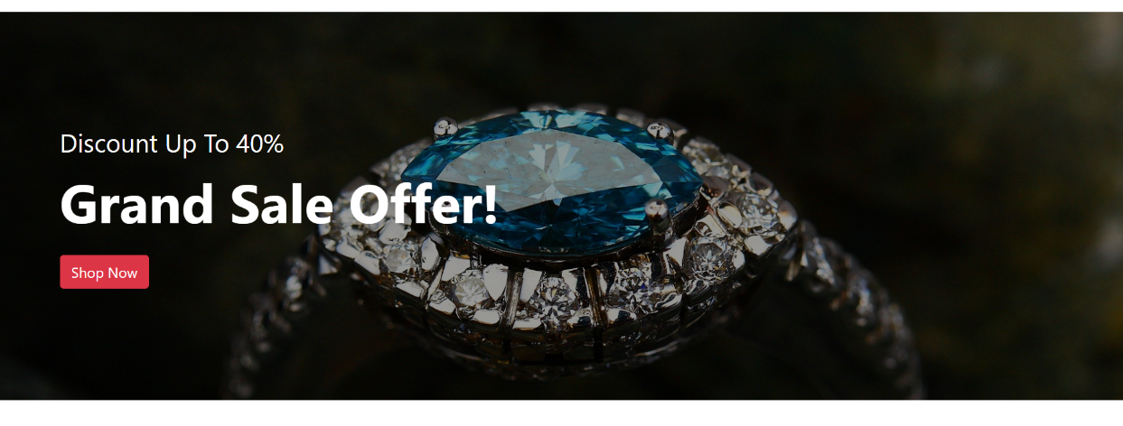

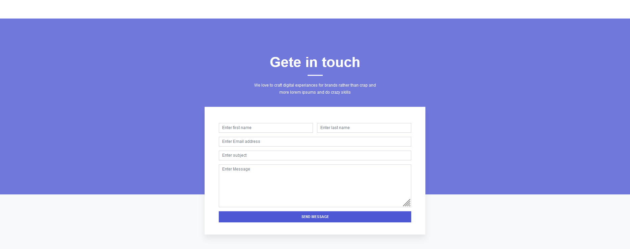

Footer

­